**Project Development Phase**

**Model Performance Test**

|  |  |
| --- | --- |
| Date | 28 June 2025 |
| Team ID | LTVIP2025TMID45505 |
| Project Name | CleanTech: Transforming Waste Management with Transfer Learning |
| Maximum Marks |  |

**Model Performance Testing:**

Project team shall fill the following information in model performance testing template.

|  |  |  |  |
| --- | --- | --- | --- |
| **S.No.** | **Parameter** | **Values** | **Screenshot** |
|  | Model Summary | VGG16 pre-trained model with custom top layers  GlobalAveragePooling   * Dense(128, relu) * Dense(3, softmax) |  |
|  | Accuracy | Training Accuracy – 0.96  Validation Accuracy -0.99 |  |
| 3. | Fine Tunning Result( if Done) | Validation Accuracy -0.99 |  |

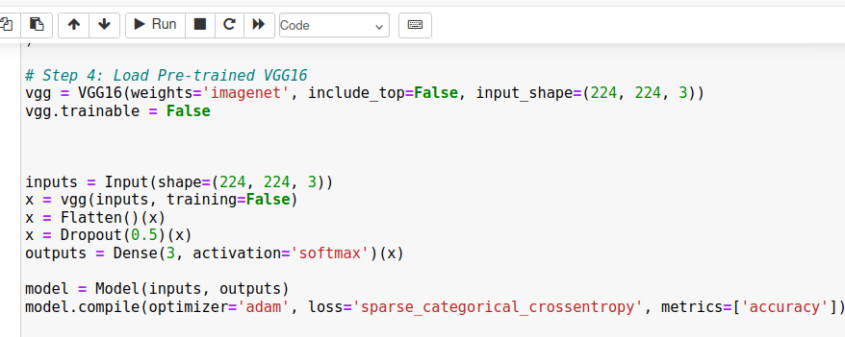

1.

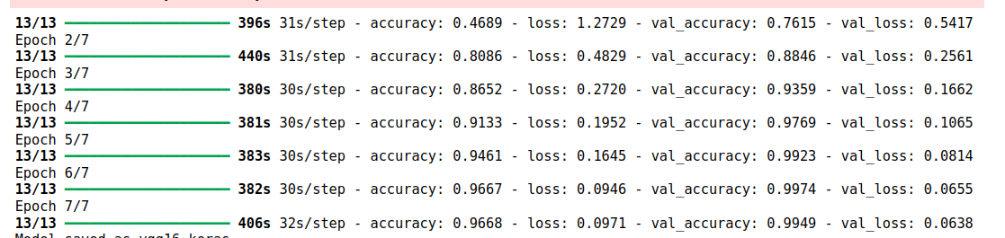

2.